NAME: H.V.S.VYSHNAVI
ROLLNO: 2403A51182
BATCHNO: 06
TASK1:
A travel company wants to show real-time weather updates for its customers. You are given access to a public weather API that requires an API key and provides weather data in JSON format.
- Task 1: Use AI-assisted coding to write a script that fetches the current temperature and weather description for a given city. The script should handle errors if the API key is invalid or missing.
- Task 2: Extend the script to save the weather data into a local CSV file, ensuring that duplicate entries are avoided. Implement error handling for file I/O exceptions
PROMPT:

CODE:
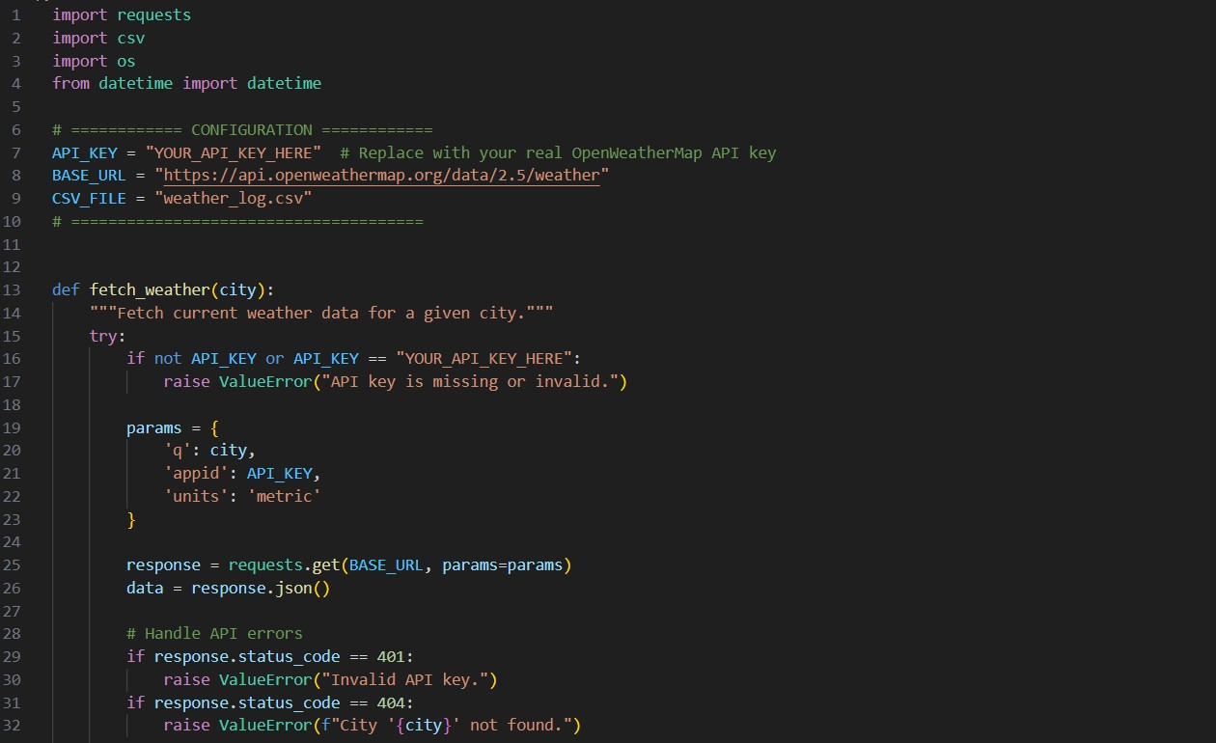
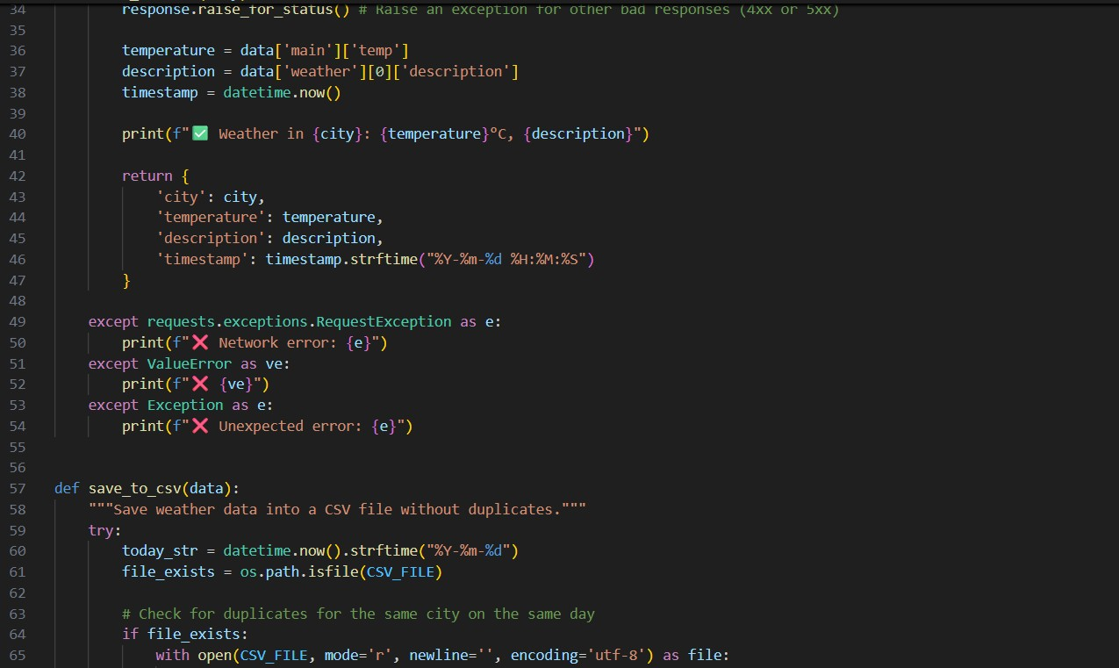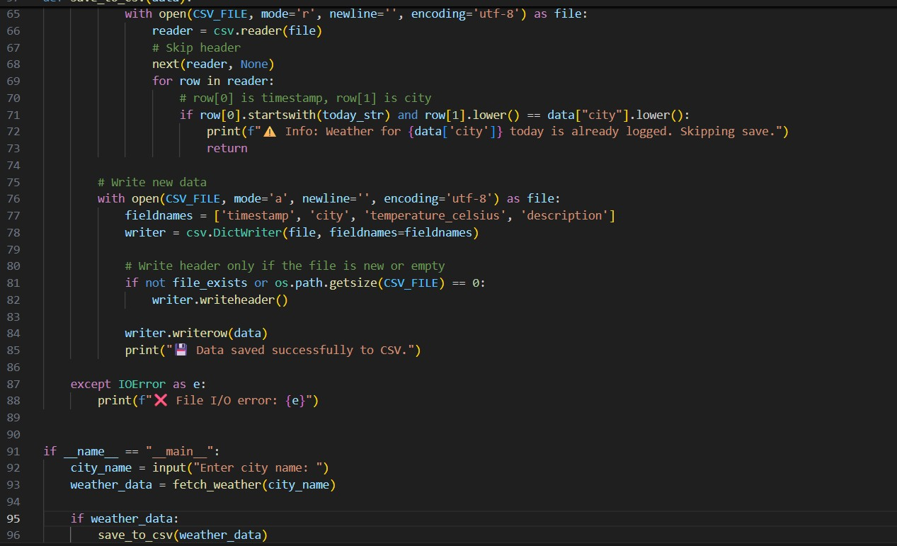
OUTPUT:
OBSERVATION:
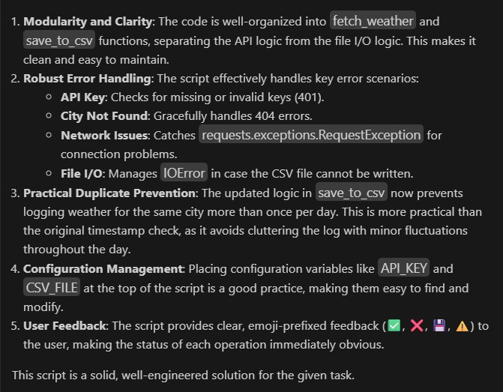
TASK2:
A financial startup needs a tool to convert amounts between currencies using an exchange rate API. However, the API occasionally fails due to server downtime.
- Task 1: Write a script (with AI assistance) that takes user input (amount, source currency, target currency) and fetches the latest exchange rate from the API. Include errors in handling invalid currency codes.
- Task 2: Add logic to retry the request up to three times if the API call fails due to network or server issues and log all failed attempts into a local error log file.
PROMPT:

CODE:
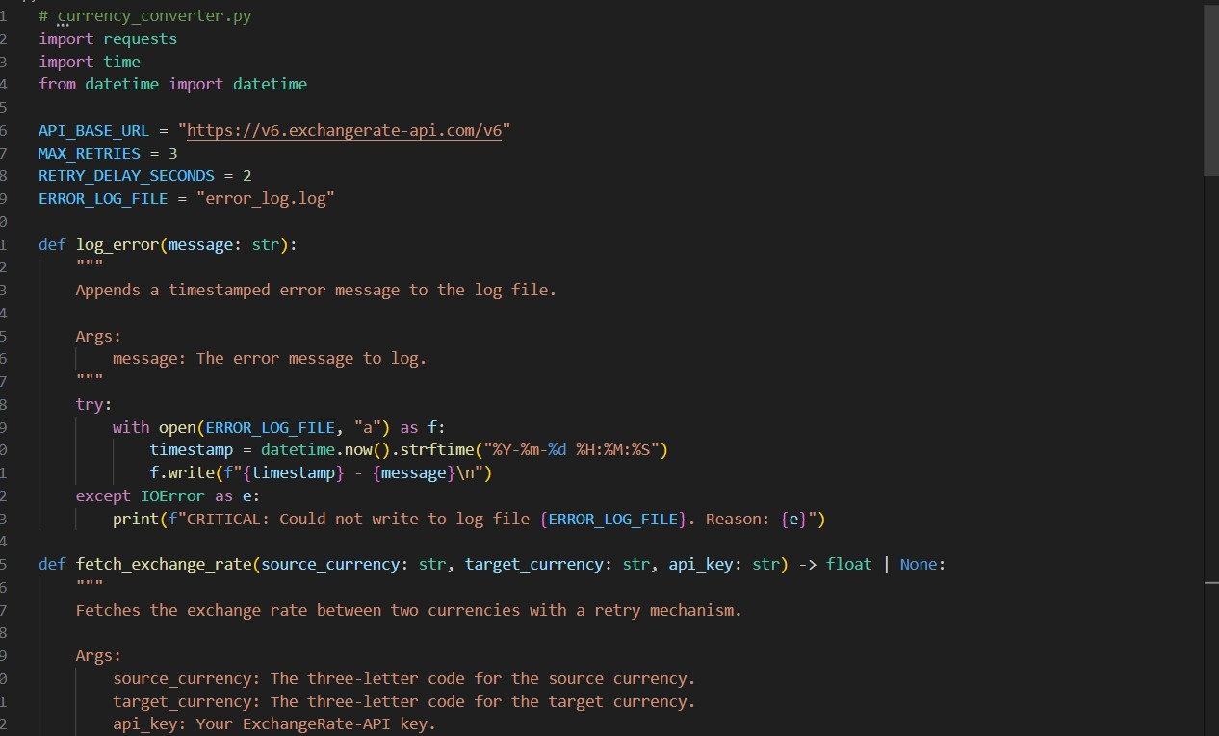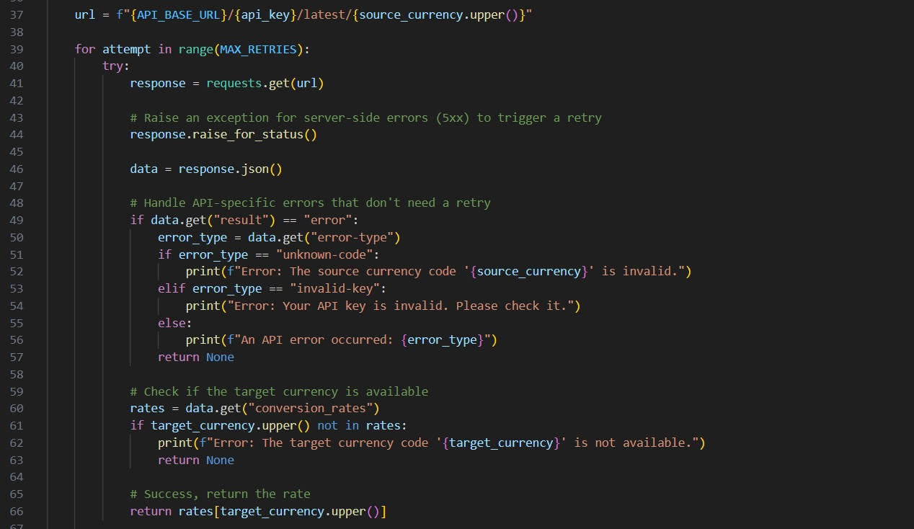
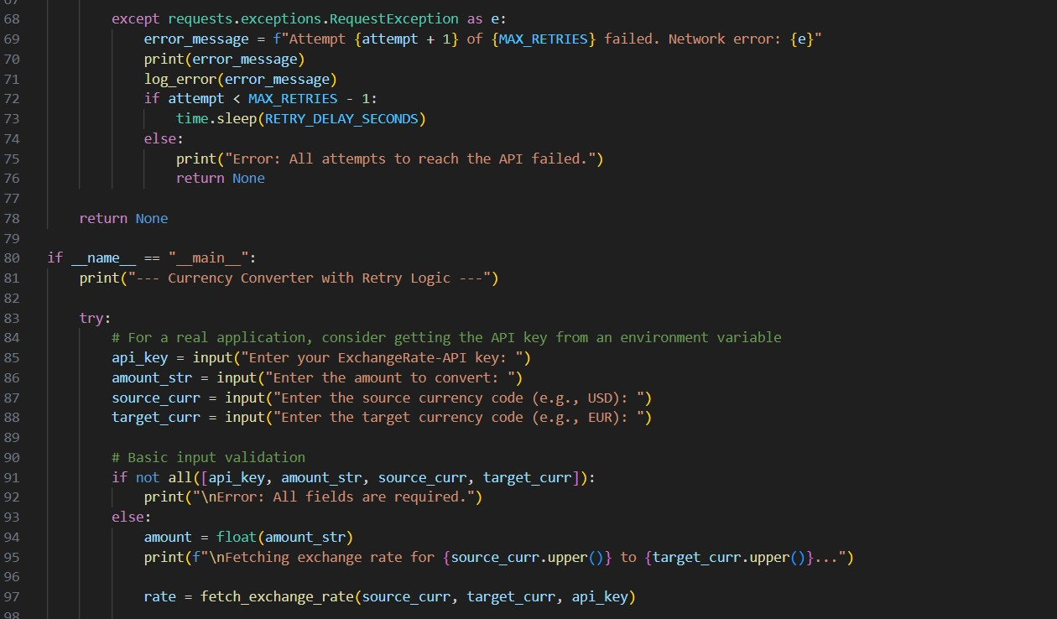
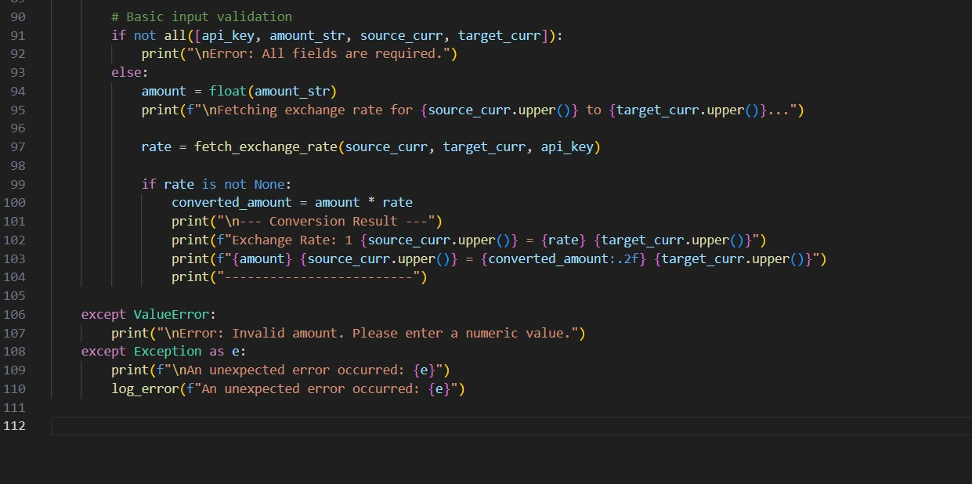
OUTPUT:
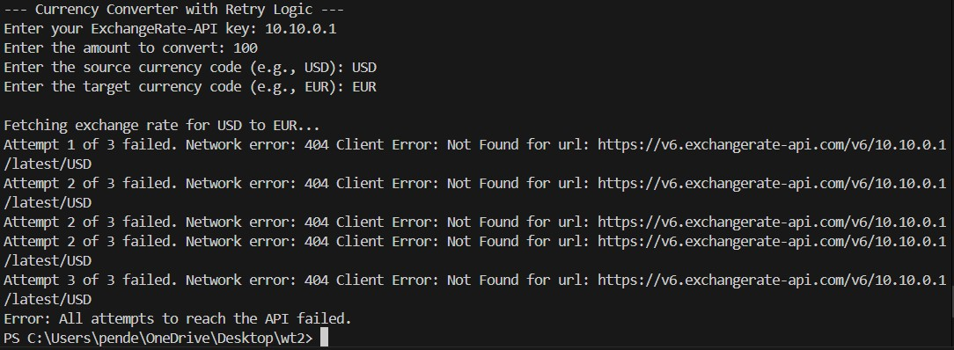
OBSERVATION:
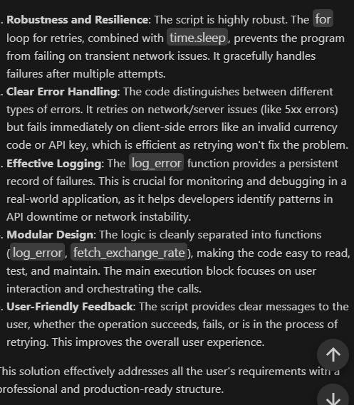
TASK3:
A news aggregator wants to display the latest technology news headlines using a news API. Sometimes, the API responds slowly or returns incomplete data.
- Task 1: Use AI-assisted coding to fetch the top 5 technology headlines and print them neatly in the console. Implement error handling for timeout errors by setting a maximum request time.
- Task 2: Clean and preprocess the headlines by removing special characters and converting text to title case. Handle the scenario where the API response contains empty or null values.

PROMPT:

CODE:
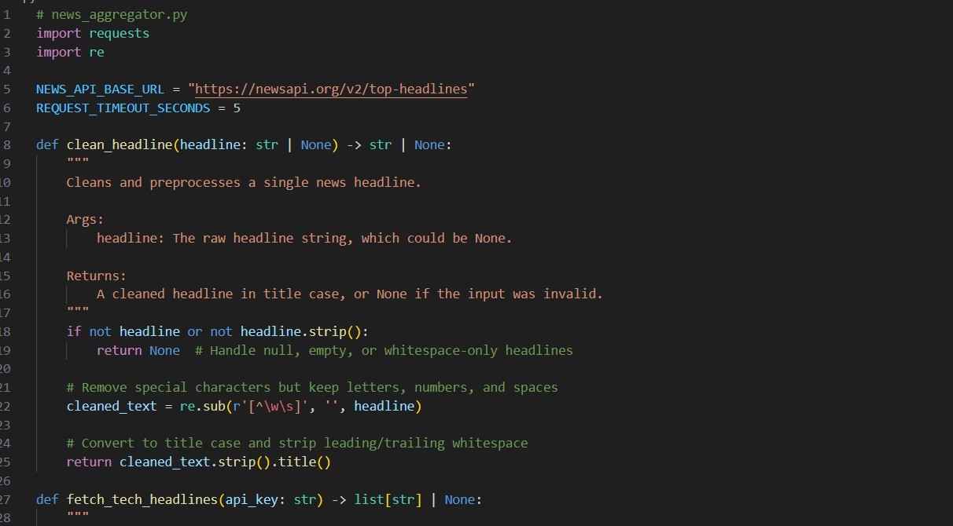
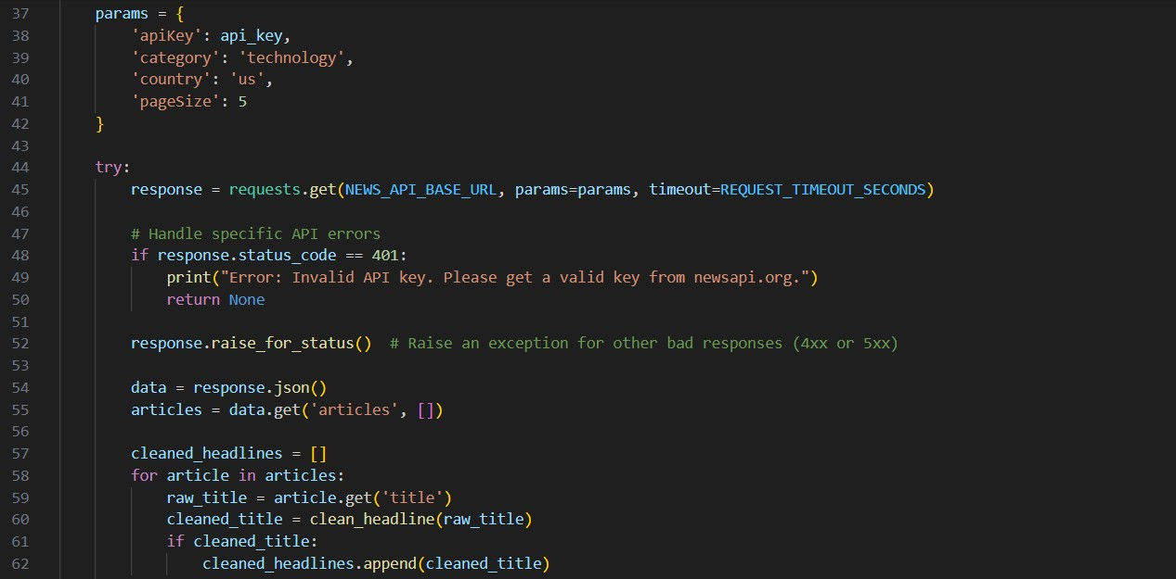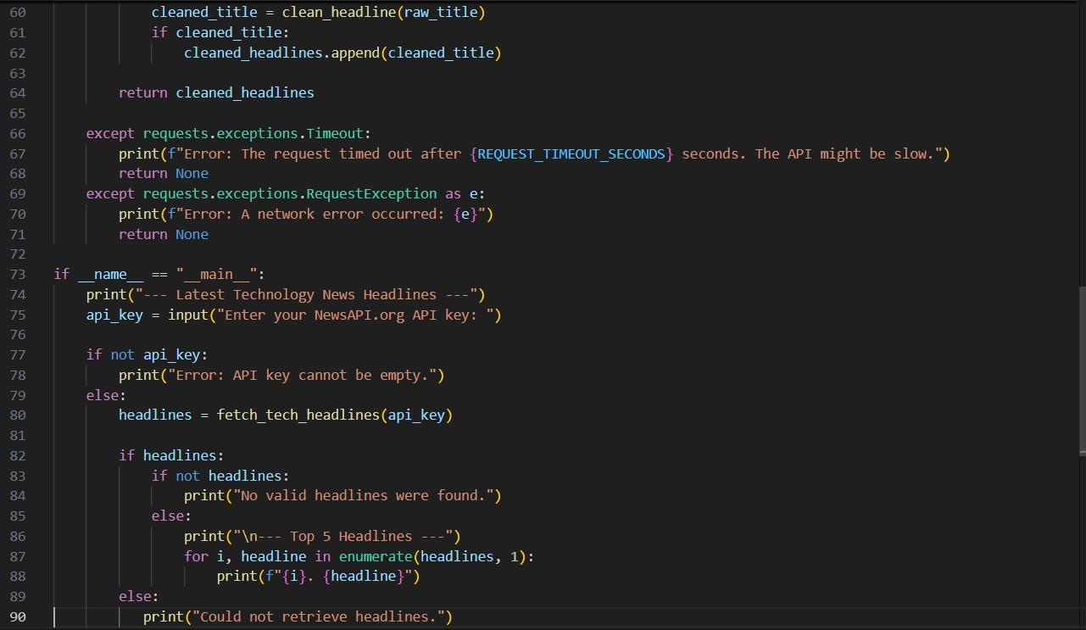
OUTPUT:
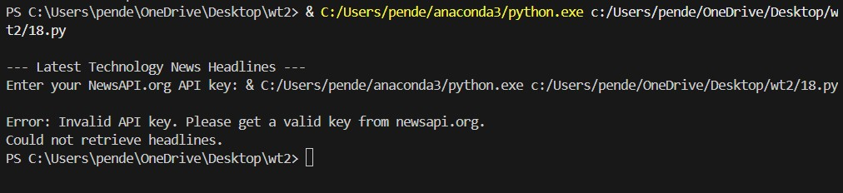
OBSERVATION:
